Rushi Patel 100615230

Yash Patel 100621177

Jeet Desai 100635399

Operating Systems Final Project Report

1. How many processes can be in the running/executing state simultaneous (number of threads).

* This depends on the number of cores a laptop has. As the cores on the laptop increases the number of threads that can run simultaneously increases. For this project there are three threads that need to run. However, for the cases of thread 1 and thread 2, they need to run simultaneously and only after the execution of the first two threads, thread 3 can finally run.

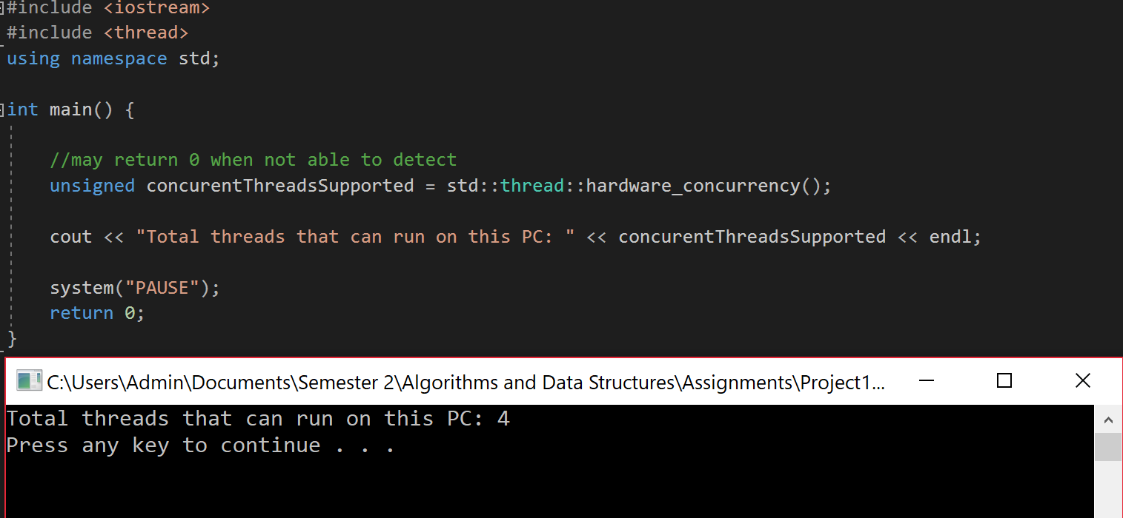

Here is a test that was done on one of our laptops in visual studio c++ to check how many threads can run concurrently.

2. How does the operating system use interrupts? (interrupts methods)

* Interrupts are essentially signals that are sent to the CPU by I/O devices. They notify the CPU to halt its current activities and execute the signal. In this project we are using a software interrupt where we are telling the OS to perform a system call requested by the program. The system call is communication which signals the program that priority packet 2 is detected.

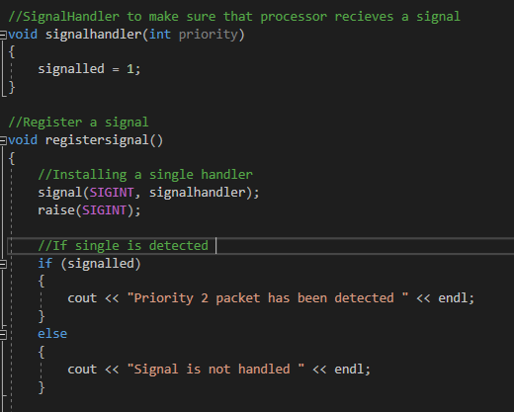

The snippet above is our signal implementation. To implement this, we first had to define the signal class “#include signal.h”. We are using SIGINT (Signal Interrupt) which is a created by the user. In the registerSignal() function we are creating a signal if the condition of if/else statements match. If it’s true it is sent to where thread 2 is functioning. If it’s not true, a signal state that the signal was not handled.

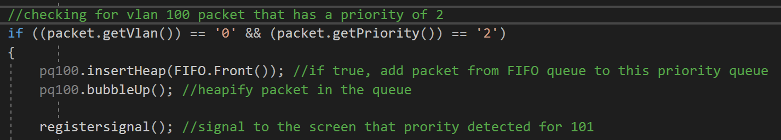

In the snippet above, we are calling the “registerSignal()” function in the if statement. The if statement checks if the packet in the queue is part of 100 and also if it has a priority of 2. If it has priority of 2, use the signal function to signal (print) to the screen/log file that priority packet is detected.

3. Why are system calls needed? Try to think of the benefits on all levels (dual-mode operation).

* The system calls are needed so users do not have to code programs to get basic functionality from the OS. The user can simply use the system call to request services from the operating system. There are total number of five system calls which are related to this project. Five system calls are process control, file management, device management, Information maintenance, and communication. These systems calls are used according to their requirements at specific part of this project.
* Process control:
  + Works in kernel level as CPU sends a request to kernel level to process all of the threads
  + These process would be the 3 threads which were created
  + Kernel level also used to signal from thread 1 to thread 2 and terminates thread 1 and thread 3 once they are finished executing

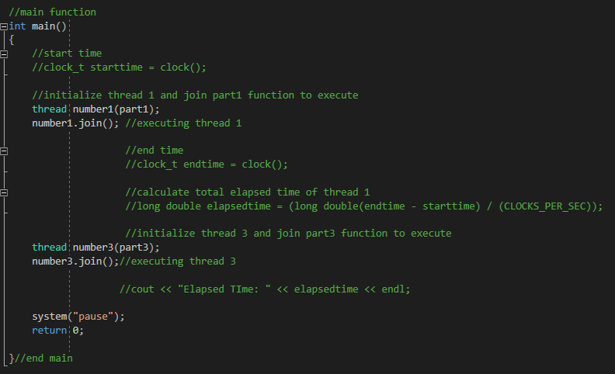

* File management:
  + This section refers to a Log file which was used to Log timestamp, payload, source and destination mac address

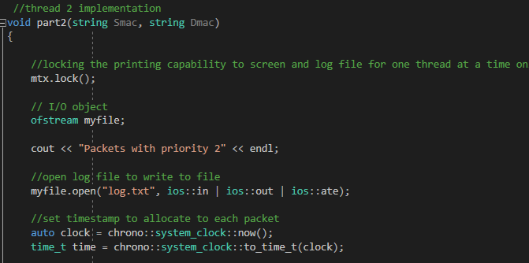

* Device management:
  + Used on user-level to print all the information regarding packets
  + This part will print all the information on the screen and log file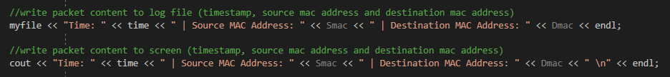
* Information maintenance:
  + Runs in kernel level since code is running inside a thread which is basically running in a kernel mode
  + 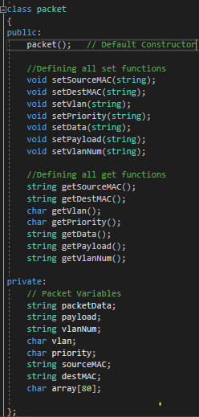A packet class was created to store information regarding a packet.
* Communication:
  + Refers to an interrupt where it is used to send a notification when a packet with priority 2 was detected.



The snippet above is used to send signal to screen/log file when priority packet is detected

**References**

“Programmatically Find the Number of Cores on a Machine.” c - Programmatically Find the Number of Cores on a Machine - Stack Overflow, stackoverflow.com/questions/150355/programmatically-find-the-number-of-cores-on-a-machine.

“1.12. System Calls.” *1.12. System Calls - Operating Systems Study Guide*, faculty.salina.k-state.edu/tim/ossg/Introduction/sys_calls.html.